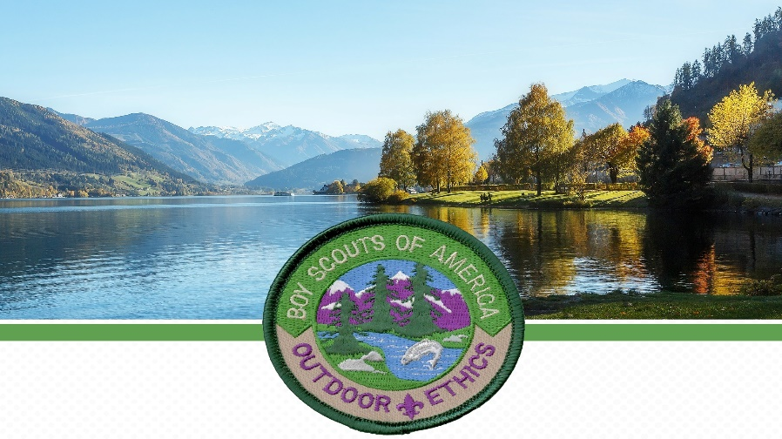

Leave No Trace Level 1 Instructor Course

Theodore Naish Scout Reservation
May 3–5, 2024 | October 25–27, 2024
Friday Check-in Starts at 5:30 pm

Class starts promptly at 7:00 pm on Friday. Check-out is at noon on Sunday.

The Leave No Trace Trainer Level 1 Instructor Course will provide Scouts, Scouters, Venturers and Unit Commissioners that successfully complete course requirements with recognition as a Leave No Trace Level 1 Instructor in BSA and the Leave No Trace Center for Outdoor Ethics. Youth and Adults can use this to train both non-scouting and scouting audiences in the 7 Principles of Leave No Trace. This course will meet BSA Leave No Trace National Camp Standards, develop and expand the knowledge of Leave No Trace principles and skills, and complete requirement #5 of the Outdoor Ethics Awareness Award.

A Leave No Trace Level 1 Instructor Course is highly recommended for Scouts BSA who wish to hold the Outdoor Ethics Guide position in their Unit and for those attending any High Adventure Camp.



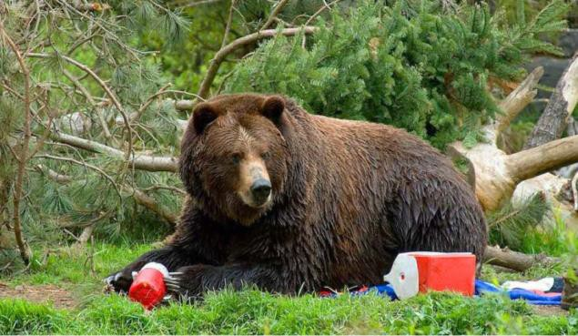

Cost with food and course materials will be $65.00 per participant.
Course is open to all scouts and scouters 14 years and older.
The course will consist of 2 overnights, class work, and outdoor experiences.
Informational packets to follow once enrolled.

More Information Contact:
Course Director, Jenna Grubbs: jknoxgrubbs@gmail.com



Register Online | mycouncil.hoac-bsa.org/Program/36

