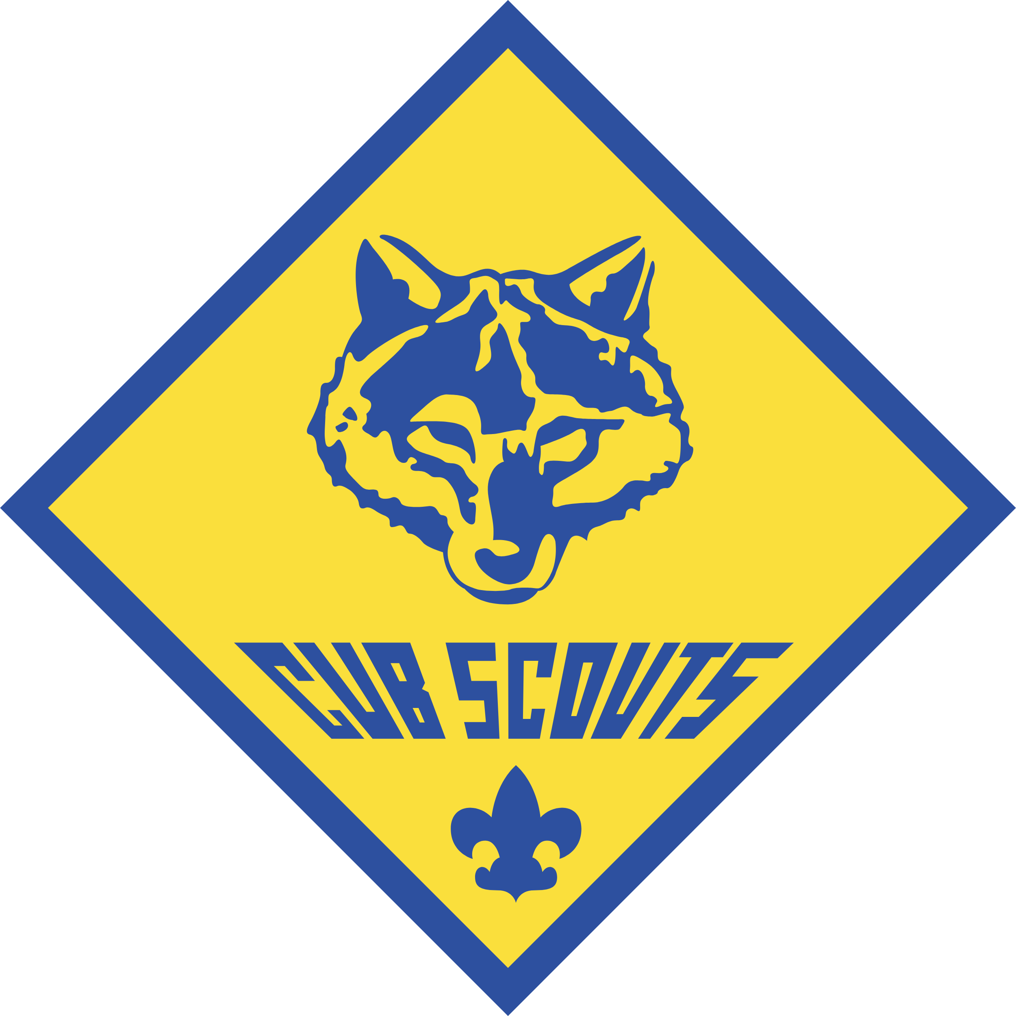


Scan to Edit
Join Cub Scout Pack ####

Welcome Families! Cub Scout Pack #### welcomes boys and girls from kindergarten through 5th Grade to join us for a year full of fun, learning, and outdoor discovery.

Our program focuses on building strong character, citizenship, and personal fitness. Through hands-on activities and family-oriented adventures, Parents can clearly see their children build confidence, develop practical life skills, and grow into leadership roles.

Weekly Meetings: Every Tuesday night at 7:00 PM | Location: [Insert Charter Organization / Address]

Our Favorite Traditions  - Family Campouts: Sleep under the stars at our annual Spring and Fall family camping trips.  - Pinewood Derby: Build and race your very own custom model wooden car.  - Community Field Trips: Go behind the scenes with local fire and police stations.  - Summer Camps: Fun day camps and resident camps at Camp Naish. | Upcoming Key Dates  - August 8: Back to Pack & Ice Cream Social  - August 15: Pack Recruitment Information Night  - August 22 & 29: New Parent Orientation  - September 29–30: Fall Family Campout

Meet the Leaders
Role / Group | Name | Contact Info
Cubmaster | [Insert Name] | [Email / Phone]
Committee Chair | [Insert Name] | [Email / Phone]
Advancement Chair | [Insert Name] | [Email / Phone]
Lion Den Leader (Kindergarten) | [Insert Name] | [Email / Phone]
Tiger Den Leader (1st Grade) | [Insert Name] | [Email / Phone]
Wolf Den Leader (2nd Grade) | [Insert Name] | [Email / Phone]
Bear Den Leader (3rd Grade) | [Insert Name] | [Email / Phone]
Webelos Den Leader (4th Grade) | [Insert Name] | [Email / Phone]
Arrow of Light Leader (5th Grade) | [Insert Name] | [Email / Phone]

[ QR CODE / URL PLACEHOLDER HERE ]
Scan or visit our website to register online!
Turn page over for the full 2026–2027 Annual Pack Calendar →

Pack #### Annual Calendar

Planned Activities & Meetings for the 2026–2027 Scouting Year

Note: Tuesdays not specifically listed as Pack Meetings or large events are designated for regular Den Meetings at 7:00 PM at your den's specific meeting location.

July 2026  19th: Pack Picnic @ Public Park  31st: Pack Field Trip @ Local Fire Station | August 2026  8th: Back to Pack & Ice Cream Social (7pm)  15th: Pack Recruitment Night (6-8pm @ School)  22nd: Parent Orientation (7pm)  29th: Pack Meeting & Orientation (7pm) | September 2026  5, 12, 19: Den Meetings (7pm)  26th: Pack Meeting (7pm)  29–30: Fall Family Campout @ American Legion Farm
October 2026  3, 10, 17, 24: Den Meetings  TBD: Raingutter Regatta  31st: Pack Meeting (7pm) | November 2026  7, 14, 21: Den Meetings (7pm)  28th: Pack Meeting (7pm) | December 2026  5, 12: Den Meetings (7pm)  19th: Pack Meeting (7pm)
January 2027  9, 16, 23: Den Meetings (7pm)  30th: Pack Meeting (7pm) | February 2027  6, 13, 20: Den Meetings (7pm)  27th: Blue & Gold Banquet (7pm) | March 2027  5, 12, 19: Den Meetings (7pm)  26th: Pack Meeting (7pm)
April 2027  2, 9, 16, 23: Den Meetings  26–27: Spring Family Campout  30th: Pack Meeting (7pm) | May 2027  7, 14, 21: Den Meetings (7pm)  28th: Pack Meeting (7pm) | June 2027  TBD: Pack Summer Field Trip  Early June: Tiger Camp  Mid-June: Wolf & Bear Camps  Late June: Webelos / AOL Camp  All Month: Camp Naish Summer Camp




NEW FAMILY RESOURCES
Welcome2Scouting Linktree
ABOUT OUR COUNCIL
Heart of America Council Website

Scouting builds character and memories that last a lifetime. Come join the adventure!

